

PROBLEM STATEMENT

Day 21 : Module_shift
Day 22 : Module_shift8
Day 23 : Module_add
Day 24 : Module_fadd
Day 25 : Module_cseladd
Day 26 : Module_addsub
Day 27 : Alwaysblock1
Day 28 : Alwaysblock2
Day 29 : Always_if
Day 30 : Always_if2

DAY:21 Module_shift
Problem Statement:
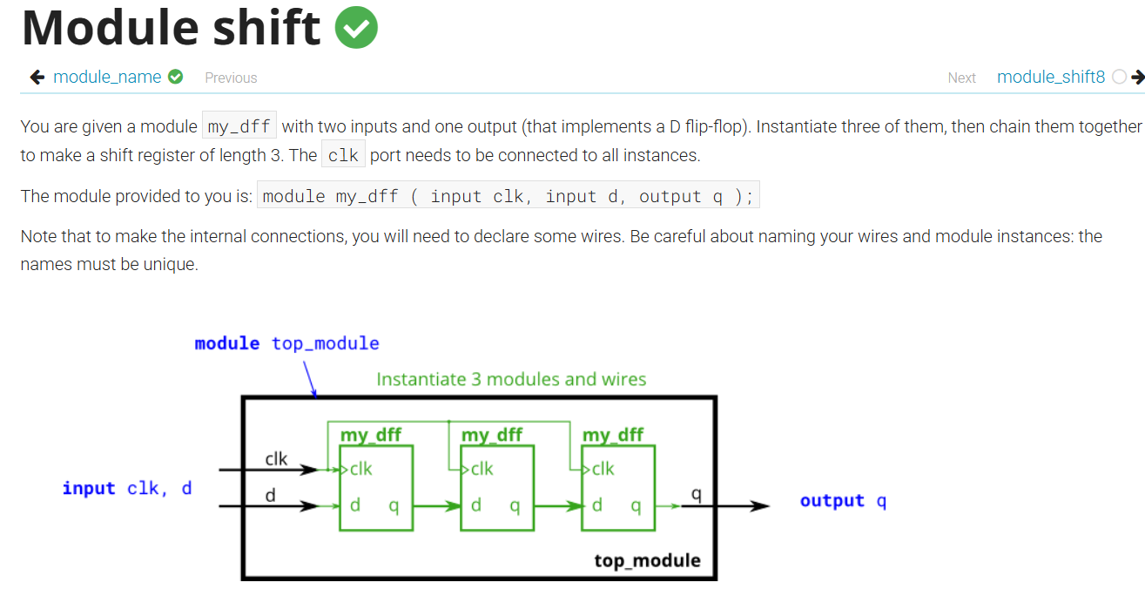
Module Declaration:
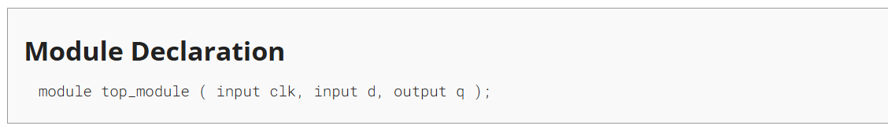
Solution:
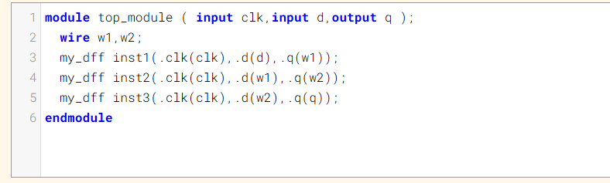

Code:
module top_module ( input clk,input d,output q );
wire w1,w2;
my_dff inst1(.clk(clk),.d(d),.q(w1));
my_dff inst2(.clk(clk),.d(w1),.q(w2));
my_dff inst3(.clk(clk),.d(w2),.q(q));
endmodule
Timing Diagram:
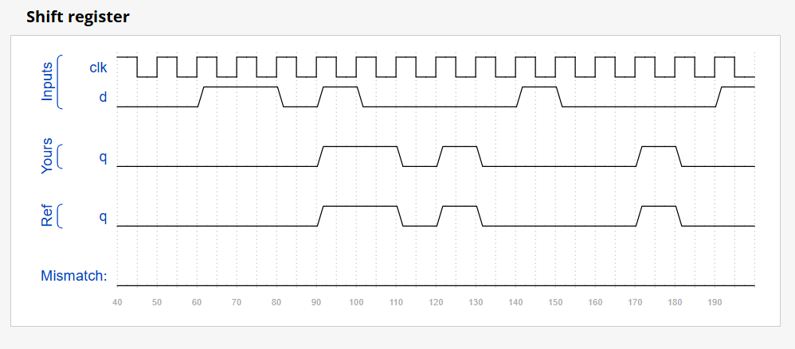

DAY:22 Module_shift8
Problem Statement:
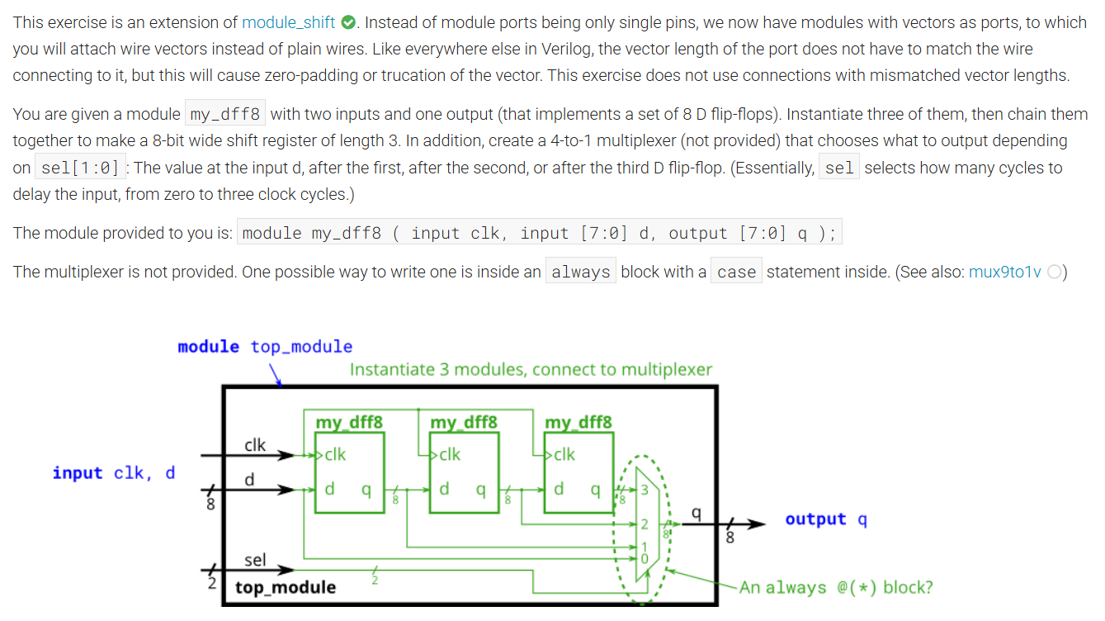
Module Declaration:
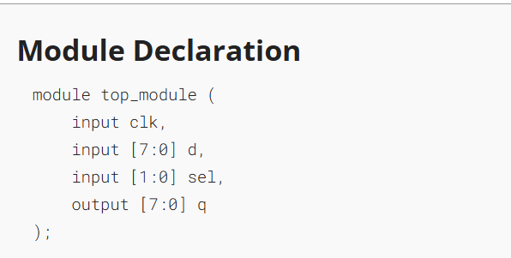

Solution:
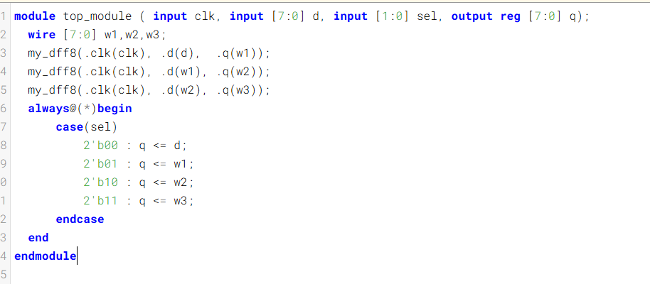
Code:
module top_module ( input clk, input [7:0] d, input [1:0] sel, output reg [7:0] q);
wire [7:0] w1,w2,w3;
my_dff8(.clk(clk), .d(d), .q(w1));
my_dff8(.clk(clk), .d(w1), .q(w2));
my_dff8(.clk(clk), .d(w2), .q(w3));
always@(*)begin
case(sel)
2'b00 : q <= d;
2'b01 : q <= w1;
2'b10 : q <= w2;
2'b11 : q <= w3;
endcase
end
endmodule
Timing Diagram:
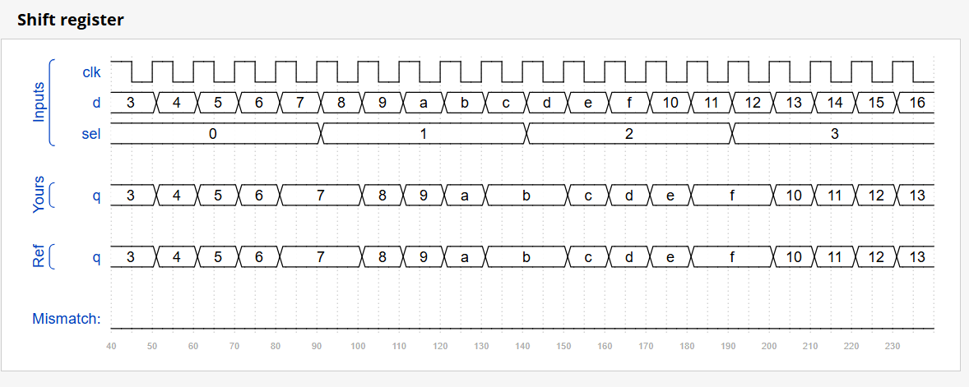

DAY:23 Module_add
Problem Statement:
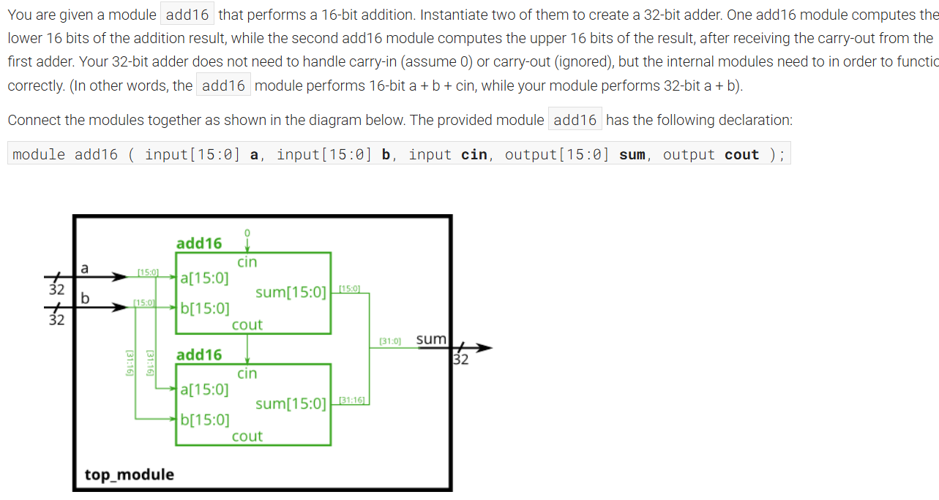

Module Declaration:
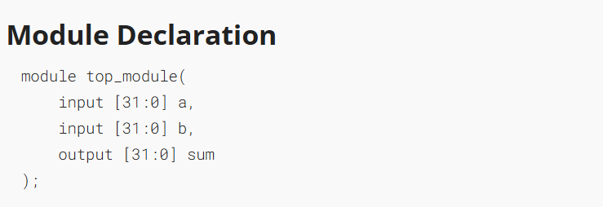
Solution:
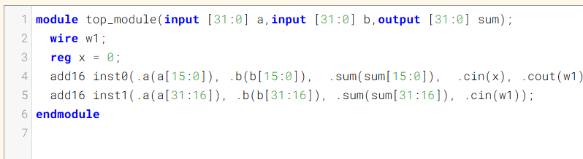
Code:
module top_module(input [31:0] a,input [31:0] b,output [31:0] sum);
wire w1;
reg x = 0;
add16 inst0(.a(a[15:0]), .b(b[15:0]), .sum(sum[15:0]), .cin(x), .cout(w1));
add16 inst1(.a(a[31:16]),.b(b[31:16]),.sum(sum[31:16]), .cin(w1));
endmodule
Timing Diagram:
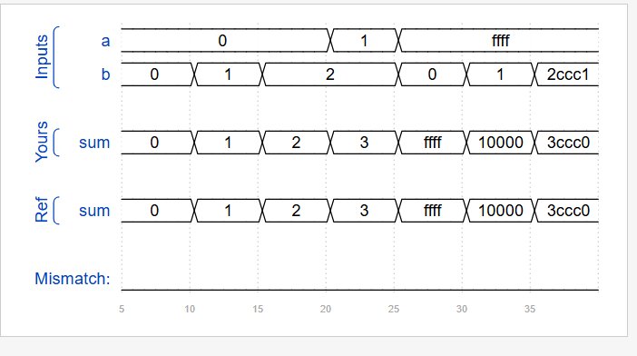

DAY:24 Module_fadd
Problem Statement:
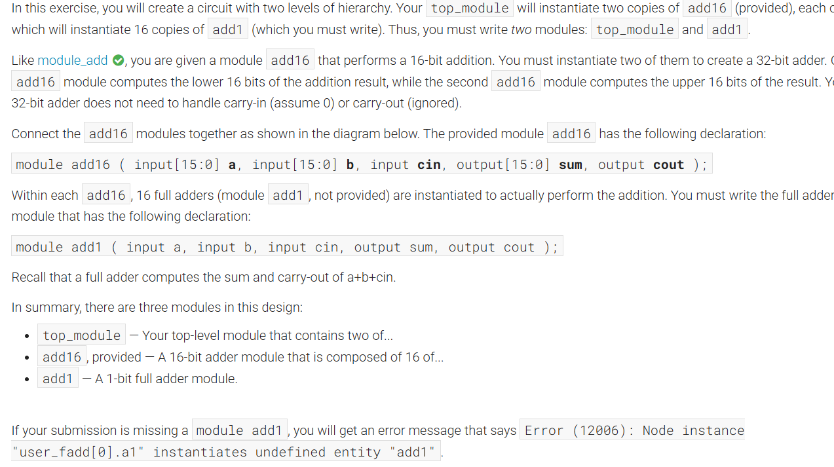
Module Declaration:
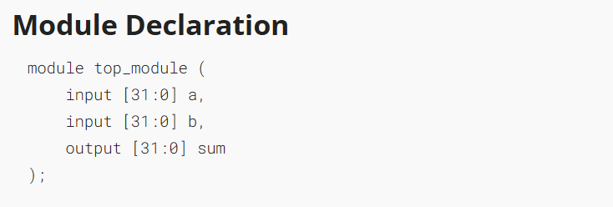

Solution:
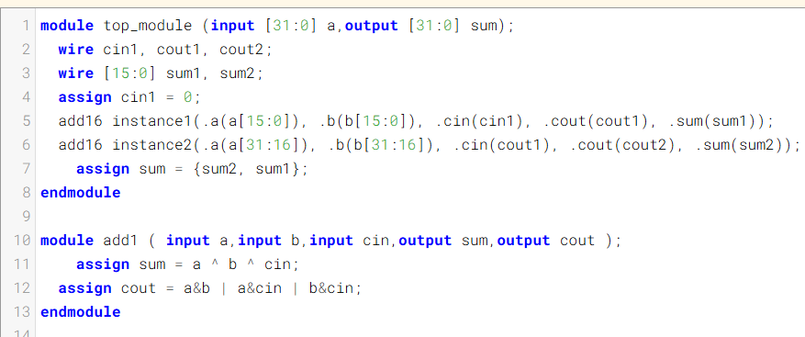

Code:
module top_module (
input [31:0] a,
input [31:0] b,
output [31:0] sum
);

wire cin1, cout1, cout2;
wire [15:0] sum1, sum2;
assign cin1 = 0;

add16 instance1(.a(a[15:0]), .b(b[15:0]), .cin(cin1), .cout(cout1), .sum(sum1));
add16 instance2(.a(a[31:16]), .b(b[31:16]), .cin(cout1), .cout(cout2), .sum(sum2));

assign sum = {sum2, sum1};

endmodule

module add1 (
input a,
input b,
input cin,
output sum,
output cout
);

assign sum = a ^ b ^ cin;
assign cout = a&b | a&cin | b&cin;

endmodule

Timing Diagram:
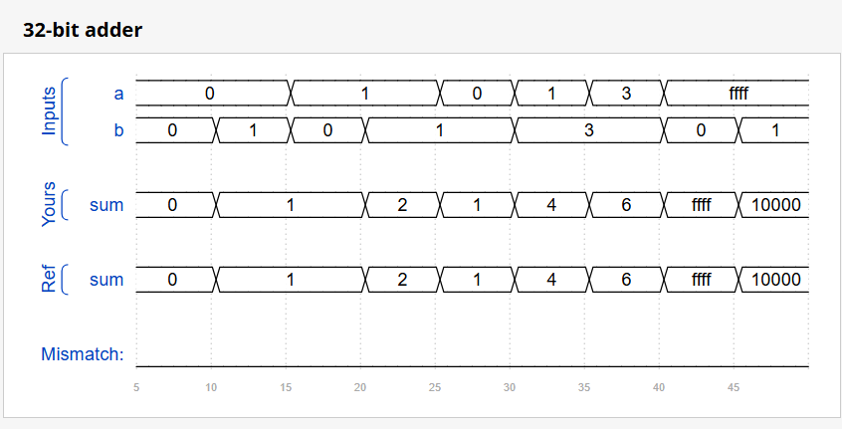

DAY:25 Module_cseladd
Problem Statement:
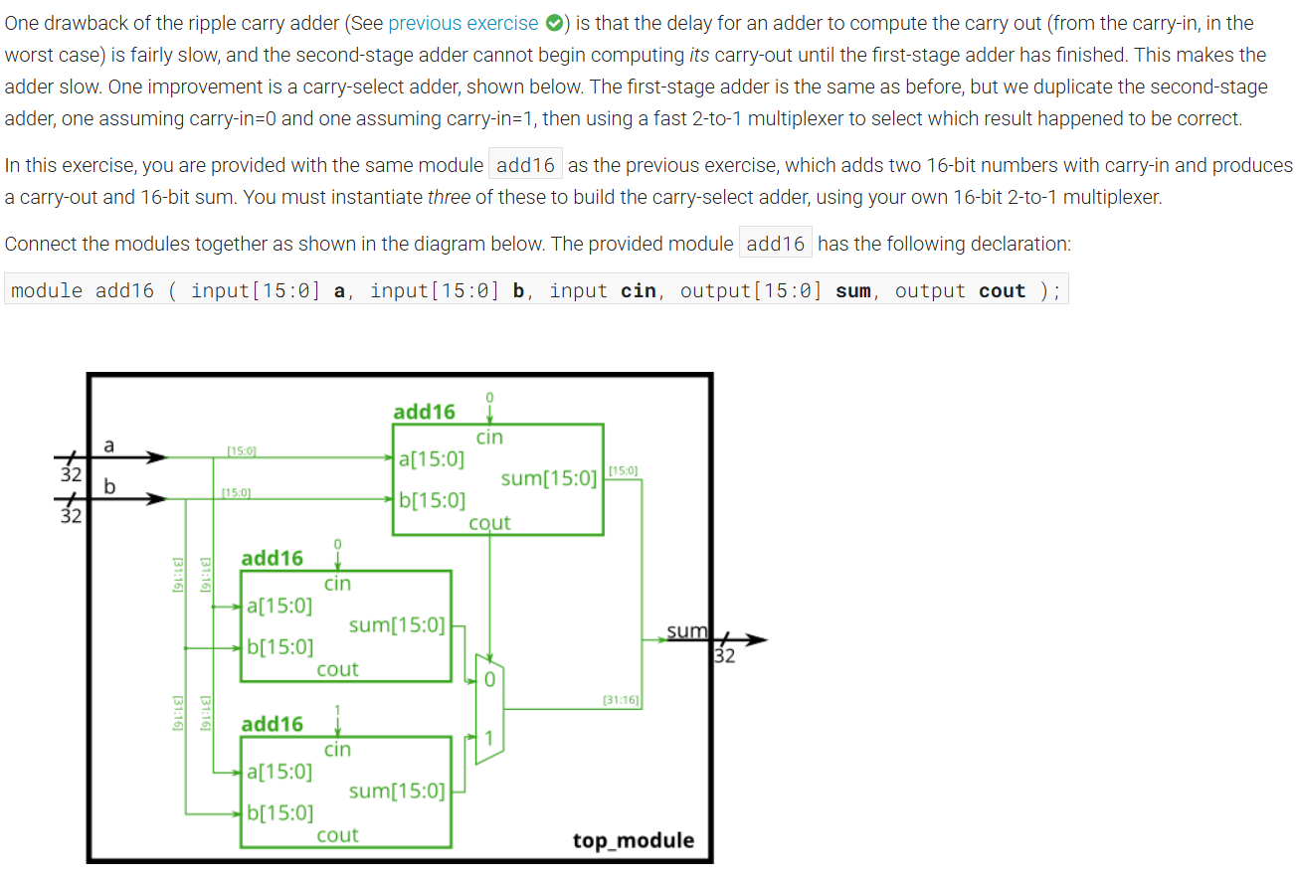
Module Declaration:
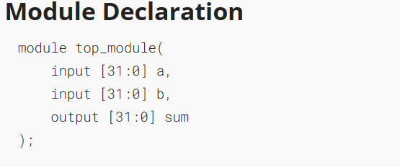

Solution:
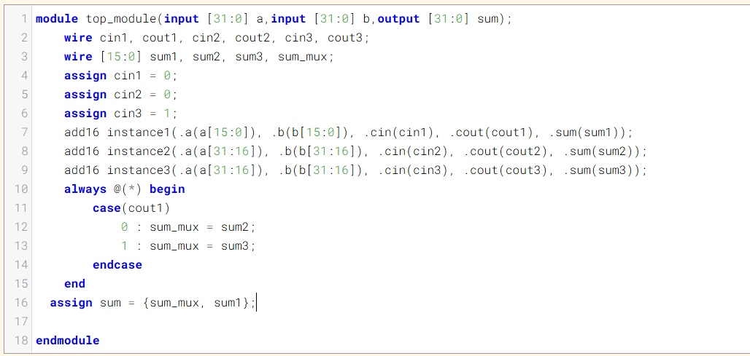
Code:
module top_module(input [31:0] a,input [31:0] b,output [31:0] sum);
wire cin1, cout1, cin2, cout2, cin3, cout3;
wire [15:0] sum1, sum2, sum3, sum_mux;
assign cin1 = 0;
assign cin2 = 0;
assign cin3 = 1;
add16 instance1(.a(a[15:0]), .b(b[15:0]), .cin(cin1), .cout(cout1), .sum(sum1));
add16 instance2(.a(a[31:16]), .b(b[31:16]), .cin(cin2), .cout(cout2), .sum(sum2));
add16 instance3(.a(a[31:16]), .b(b[31:16]), .cin(cin3), .cout(cout3), .sum(sum3));
always @(*) begin
case(cout1)
0 : sum_mux = sum2;
1 : sum_mux = sum3;
endcase
end
assign sum = {sum_mux, sum1};

endmodule
Timing Diagram:
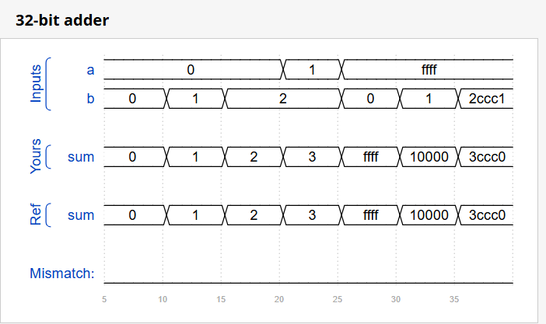

DAY:26 Module_addsub
Problem Statement:
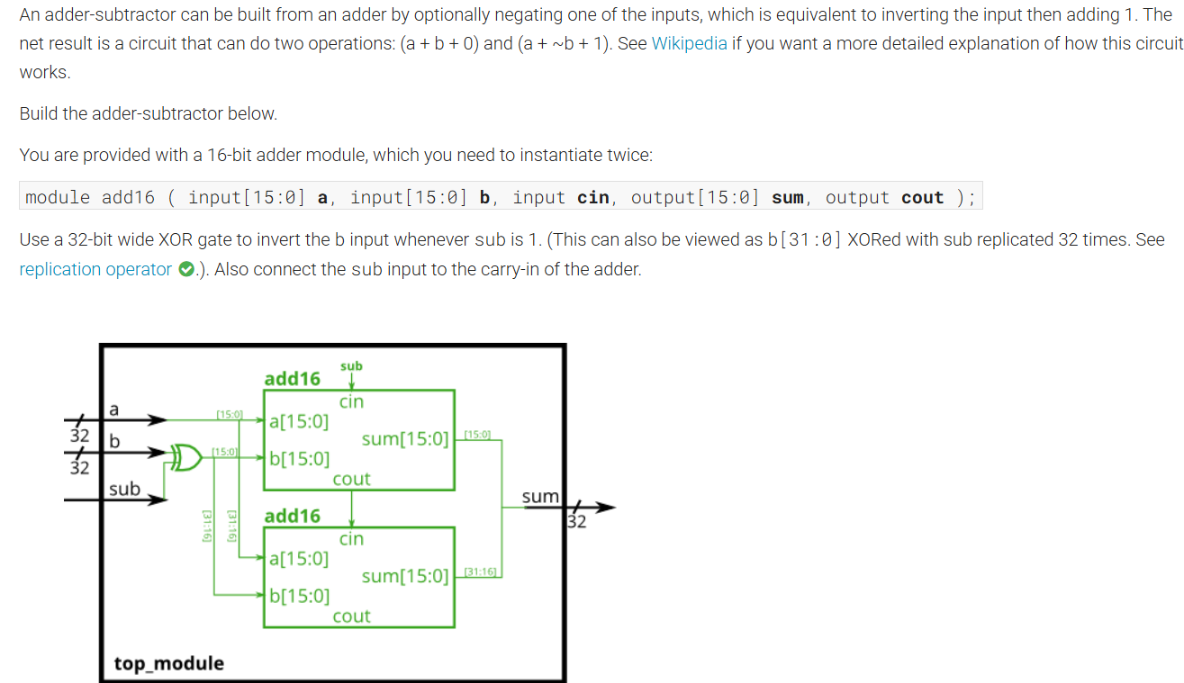

Module Declaration:
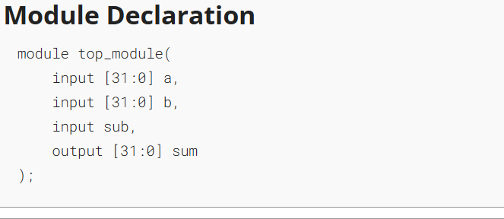

Solution:
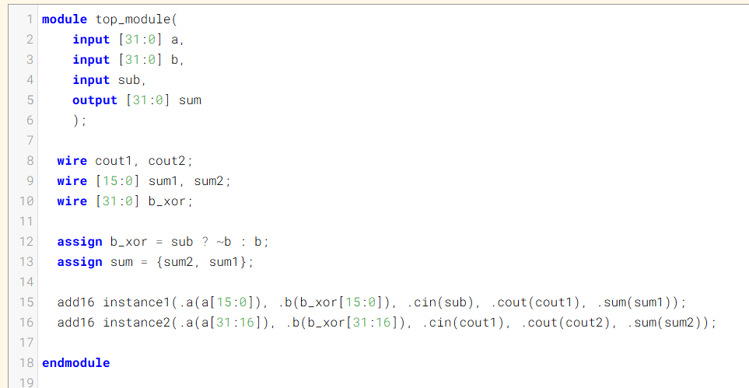
Code:
module top_module(
input [31:0] a,
input [31:0] b,
input sub,
output [31:0] sum
);

wire cout1, cout2;
wire [15:0] sum1, sum2;
wire [31:0] b_xor;

assign b_xor = sub ? ~b : b;
assign sum = {sum2, sum1};

add16 instance1(.a(a[15:0]), .b(b_xor[15:0]), .cin(sub), .cout(cout1), .sum(sum1));
add16 instance2(.a(a[31:16]), .b(b_xor[31:16]), .cin(cout1), .cout(cout2), .sum(sum2));

endmodule
Timing Diagram:
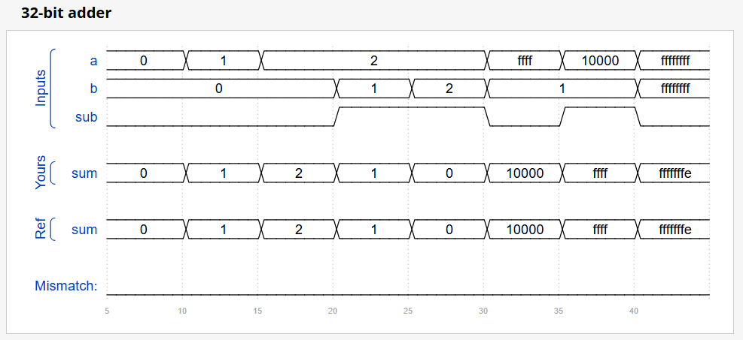

DAY:27 Alwaysblock1
Problem Statement:
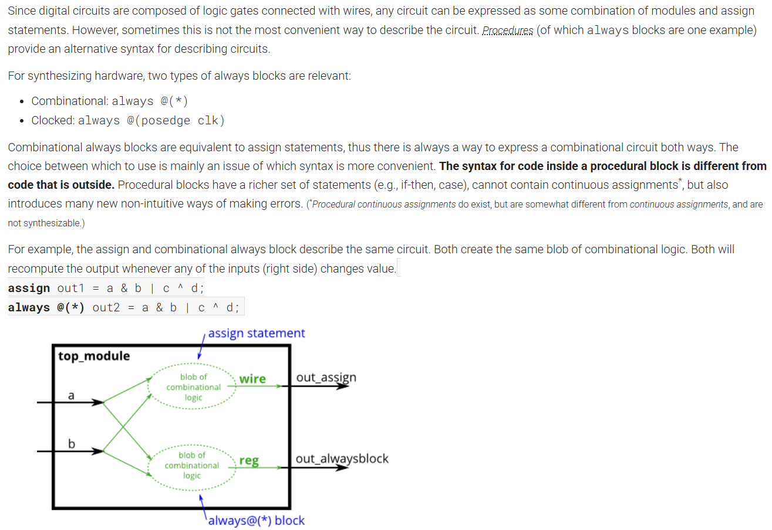
Module Declaration:
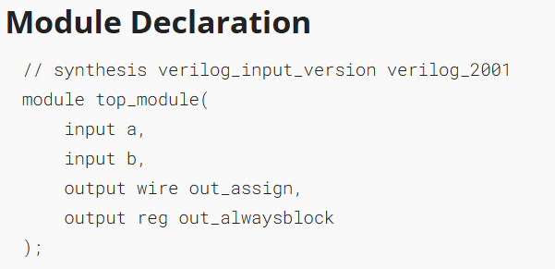
Solution:
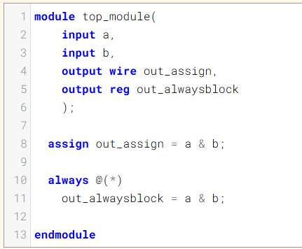
Code:
module top_module(
input a,
input b,
output wire out_assign,
output reg out_alwaysblock
);

assign out_assign = a & b;

always @(*)
out_alwaysblock = a & b;

endmodule
Timing Diagram:
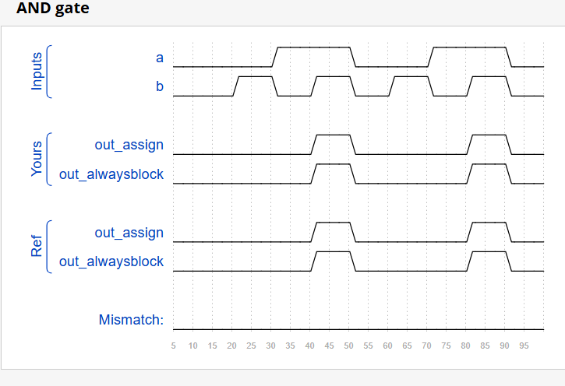

DAY:28 Alwaysblock2
Problem Statement:
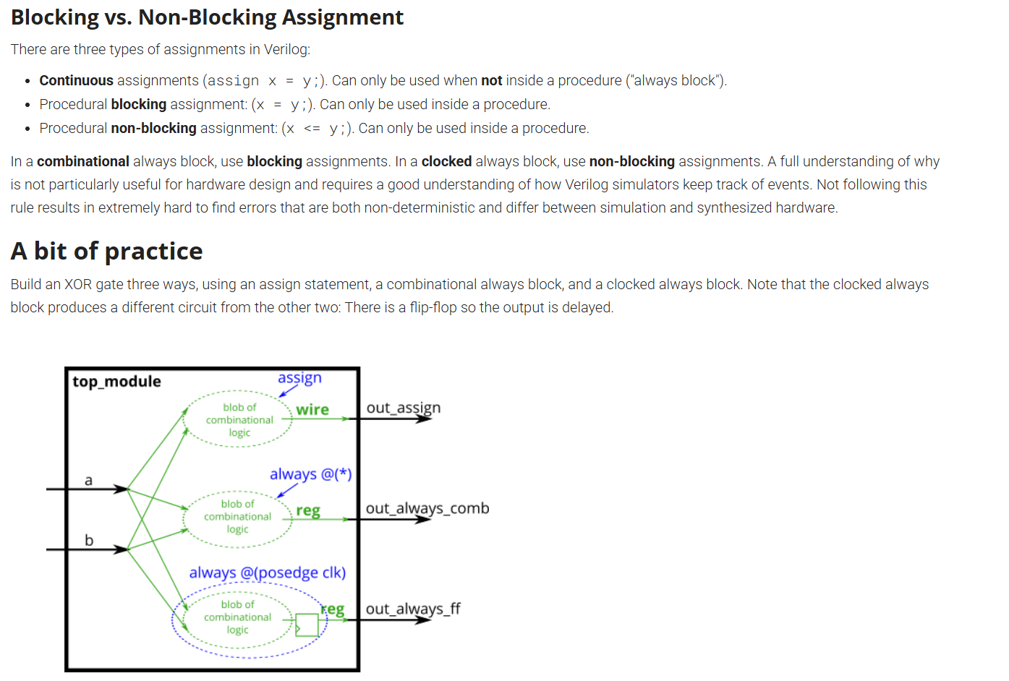

Module Declaration:
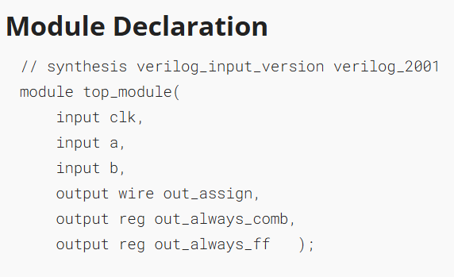
Solution:
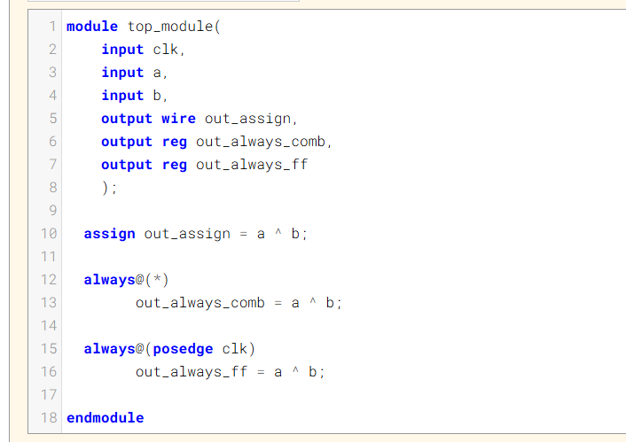
Code:
module top_module(
input clk,
input a,
input b,
output wire out_assign,
output reg out_always_comb,
output reg out_always_ff
);

assign out_assign = a ^ b;

always@(*)
out_always_comb = a ^ b;

always@(posedge clk)
out_always_ff = a ^ b;

endmodule

Timing Diagram:
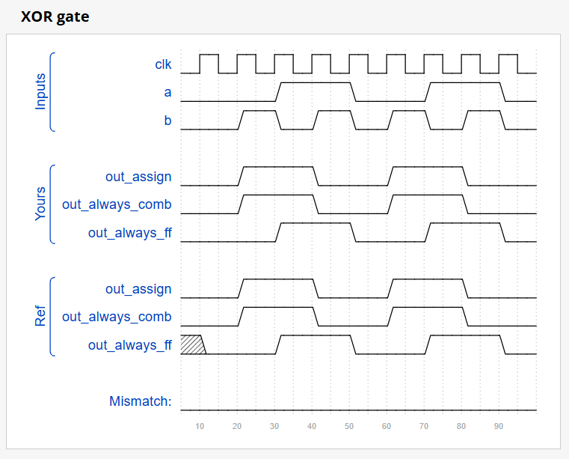
DAY:29 Always if
Problem Statement:
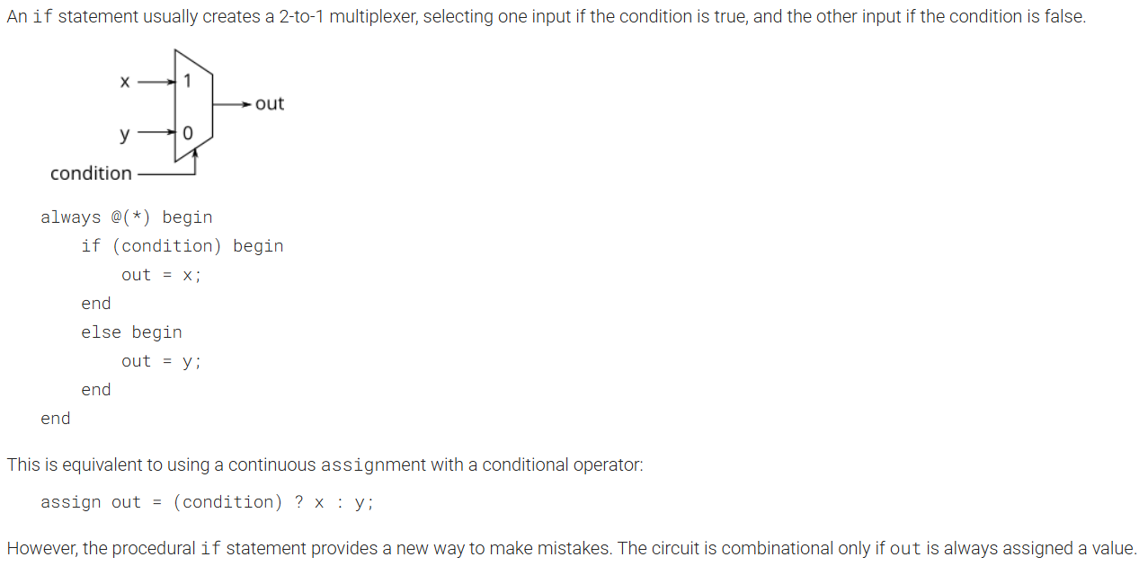
Module Declaration:
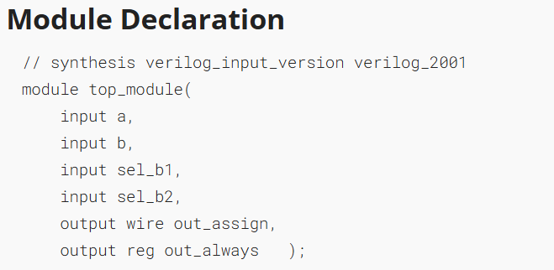
Solution:
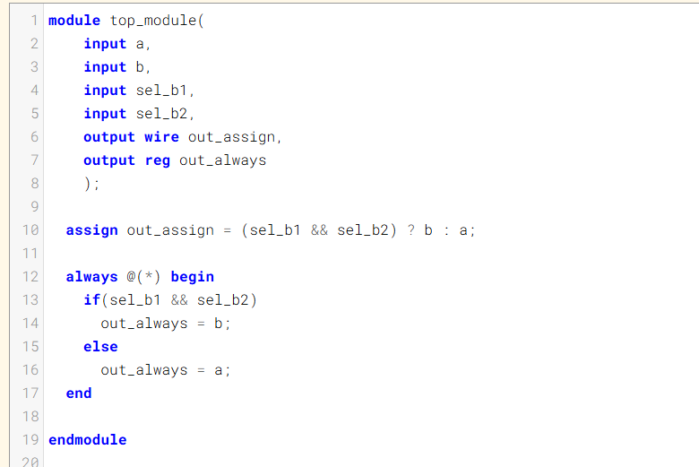

Code:
module top_module(
input a,
input b,
input sel_b1,
input sel_b2,
output wire out_assign,
output reg out_always
);

assign out_assign = (sel_b1 && sel_b2) ? b : a;

always @(*) begin
if(sel_b1 && sel_b2)
out_always = b;
else
out_always = a;
end

endmodule

Timing Diagram:
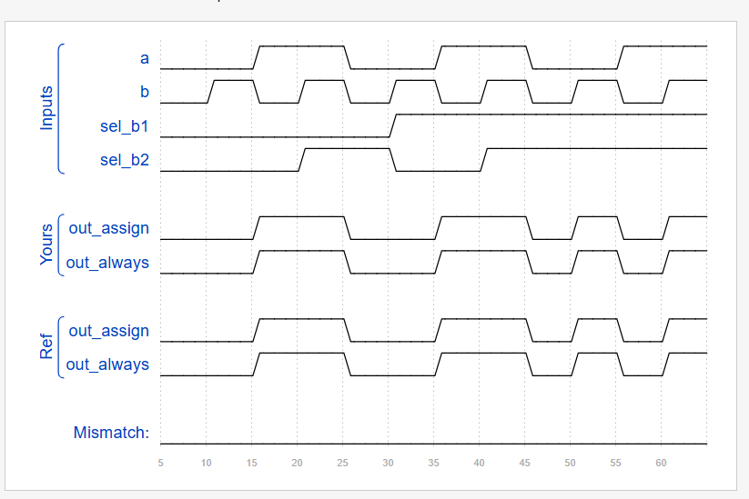
DAY:30 Always if2
Problem Statement:
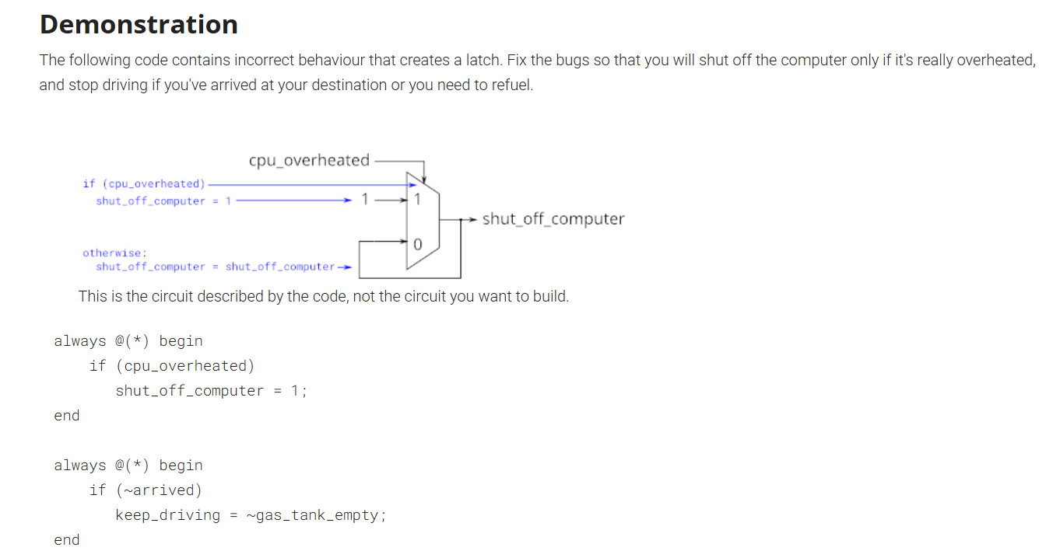
Module Declaration:
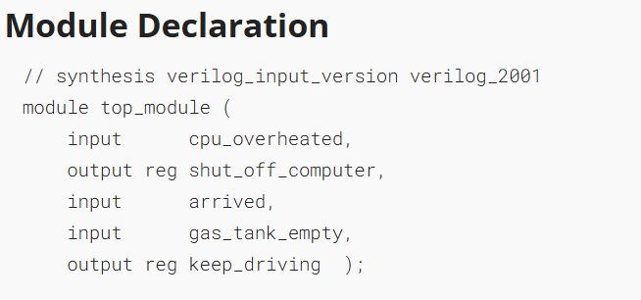
Solution:
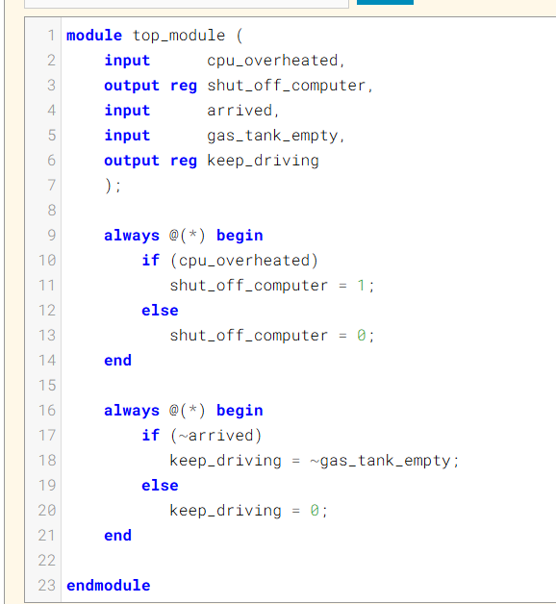
Code:
module top_module (
input cpu_overheated,
output reg shut_off_computer,
input arrived,
input gas_tank_empty,
output reg keep_driving
);

always @(*) begin
if (cpu_overheated)
shut_off_computer = 1;
else
shut_off_computer = 0;
end

always @(*) begin
if (~arrived)
keep_driving = ~gas_tank_empty;
else
keep_driving = 0;
end

endmodule
Timing Diagram:
